Policies in ArchTrace System
Leo Murta (murta@ics.uci.edu), 8/22/2004

Scenario
After boot, ArchTrace shows all existing architectural elements, configuration items, and maps among architectural elements and configuration items. However, these maps, which were created at some moment in the past, should be updated during the software evolution.
The ArchTrace elements, mainly represented by architectural elements, configuration items and mappings, are changed by the ArchTrace actors, which comprises users (software engineers, configuration managers, etc.), CASE tools for architecture editing and CM systems, as shown in Figure 1.
ArchTrace
CASE tool
(eg.: ArchStudio)
CM system
(eg.: Subversion)
User
Figure 1: Actors of ArchTrace system
Basically, users interact direct in the ArchTrace graphical user interface to establish mappings among architectural elements and configuration items. On the other hand, architecture-based CASE tools and CM systems inform ArchTrace about the existence of new versions of architectural elements and configuration items, respectively.
In most cases, new versions of architectural elements and configuration items imply some user intervention. This intervention is an attempt to evolve the mappings to reflect the correct relationship among the new versions of architectural elements and configuration items. However, this activity is time consuming and error prone, especially in large component-based systems.
This paper proposes an approach to minimize user intervention for update mappings. This approach is based on policies that are automatically executed when specific triggered events occurs. To do so, the hook points (shown in Section 2), types of policies (shown in Section 3) and the architecture for handling policies (shown in Section 4) are defined. Moreover, some built-in policies (shown in Section 5) are identified.

Hook points
Each possible way to change ArchTrace elements should have hook points to plug policies. These hook points are:
- mapping addition or removal (user actor)
- architectural element change (CASE tool actor)
- addition of new versions of configuration items (CM system actor)

To implement these hooks, a notification model should be used to receive information from the actor and call all policies that listen for events. Each police should implement a specific interface that has methods for the policy execution. For example: When a user clicks on an architectural element and selects the checkbox of a configuration item, ArchTrace should run all pre-mapping policies (discussed in section 3) before creating or removing the mapping. After that, ArchTrace should create or remove the mapping itself and run all post-mapping policies (also discussed in section 3).
The current implementation of ArchTrace is compatible with xArchADT (ArchStudio subsystem) and Subversion. These systems have specific mechanisms to provide notifications about evolution of architectural elements and configuration items, respectively.
The notifications about architectural elements evolution can be obtained by the implementation of method handleXArchFlatEvent(XArchFlatEvent) defined in the XArchFlatListener interface. Moreover, ArchTrace should register itself as listener of architectural changes, using the method addXArchFlatListener(XArchFlatListener) in the XArchFlatImpl class.
The notifications about configuration items evolution can be obtained by adding a post-commit script in the hooks directory of Subversion repository. This script should connect to ArchTrace to inform which configuration items have changed. In other words, ArchTrace should listen a specific TCP/IP port waiting for notifications, or use middleware system that help in this activity.

Types of policies
The types of policies that ArchTrace should be able to run are:
- Pre-mapping policies
- Post-mapping policies
- Architectural element evolution policies
- Configuration item evolution policies

The pre-mapping policies are executed just before a mapping is added to or removed from ArchTrace. This type of policy allows detection of inconsistencies among the mapping that is being created or removed and other mappings that already exist. Policies of this type can interact with the user and throw a MappingAbortedException to notify ArchTrace that the mapping should not be performed.
On the other hand, the post-mapping policies are activated after a mapping is created or removed. This allows the definition of policies that update other mappings when some mappings are effectively added or removed.
The architectural element evolution policies are executed if some architectural elements has been added, removed or changed. The most common change in an architectural element is related to its mutable state and sub-architecture. It is worth remembering that new versions of architectural elements means new (added) architectural elements, not changes in existing architectural elements. However, it is possible to find the prior versions of a given architectural element. An important assumption made by ArchTrace is that every new version of an architectural element has ALL mappings of its prior version (this should be done by the architectural versioning system, such as Menage, when creating new versions). If this assumption is not true, a policy of this type should be created do “copy” all mappings of previous architectural element version when new architectural elements are added.
Finally, the configuration item evolution policies are executed when new versions of configuration items are created in the repository. Assuming that the repository is always immutable (opposing from architectural elements, that can have some mutable/not versioned instances), it is not necessary to care about change and remove actions over versions. The main usage of policies of this type is to update existing mappings when configuration items evolve.

Policy handling architecture
The internal architecture of ArchTrace should be designed to allow easy plug/unplug of customized policies. This means that each policy type should be defined as a generic interface. Moreover, classes that implement these interfaces should have their instances loaded into ArchTrace.
The proposed approach to solve this problem should use an internal class of ArchTrace (PolicyRegister) to register all classes that implement the ArchTracePolicy interface. This class is loaded via an XML descriptor for policies. This descriptor should be consulted by PolicyRegister to detect the name of each existing class that implements a specific policy. After that, the PolicyRegister should use Java reflection API to load an instance of the policy and register it. Figure 2 shows a simplified class model of policy management following this approach.

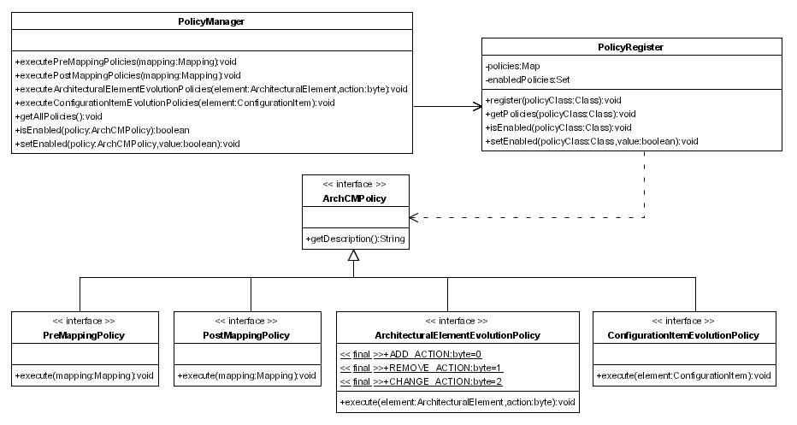
Figure 2: Simplified class model for policy management in ArchTrace

Built-in polices
The main usages of policies in ArchTrace comprise:
- Suggestion of alternative user actions
- Prohibition of a specific user action
- Execution of complementary actions
- Automatic execution of actions due to changes in ArchTrace elements
- Etc (Logging of user actions, Notification, …).

This section describes an initial list of policies that can be available into the ArchTrace release. These build-in policies are like every other policy. They can be enabled, disabled, executed and even removed from the ArchTrace. The only difference is that they come with the ArchTrace by default.

Pre-mapping build-in policies
- Detection if another version of the same configuration-item already mapped
- Detection if any sub-element or super-element of the configuration-item already mapped

Post-mapping build-in policies
- Suggestion of new mappings that are usually performed when a specific mapping is performed (data-mining of info like: “architectural elements that map to this configuration item usually map to these other configuration items”)

Architectural element evolution build-in policies
- Copy of all mappings from previous version of an added architectural element

Configuration item evolution build-in policies
- Automatic update of mappings when new versions of an already mapped configuration item are added, if the architectural element is mutable (what is the real meaning of mutable/immutable?)

